


Curriculum vitæ of

Gilbert “Alcor” Arcand
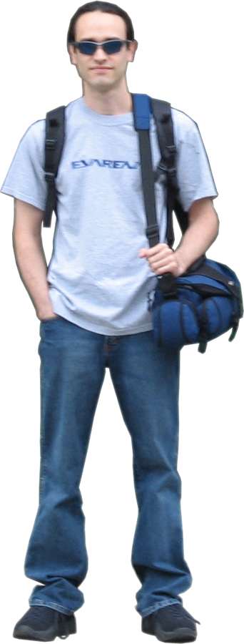

My name is Gilbert Arcand, I’m 24 years old. In the year 2000 I completed a college diploma in computer science at the Cégep de l’Abitibi-Témiscamingue. In April 2005, I finished my multimedia bachelor’s degree which was composed of a multimedia creation major as well as a 3D creation minor at the l’Université du Québec en Abitibi-Témiscamingue.

Since 1998, I do video game computer graphics and I self-thought myself most of the knowledge I’ve got. So I’m quite resourceful. Also, I have a very good knowledge of 3D modelling, animation, texturing as well as programming. I’m also quite skilful with the use of digital and video cameras .

During my bachelor’s degree, I realized a few short films in which I filmed, acted, directed, did video editing as well as special effects. The most important ones are: 341ml, Terminalcor2 and the traditional animation film Tomato: Fruit or Vegetable.

For my synthesis project, I realized a video game demo with the help of 4 other students. Evarena is a modification of the game Unreal Tournament 2004 in which the player is immersed in the universe of the Japanese manga Neon Genesis Evangelion.

I’m also a freelance 3D artist. To this day I realized more than 10 game characters modelling contracts for several companies around the world via the Internet. My greatest job was during the 2004 summer, when I worked for the Robert Lepage company ExMachina. I had 2 months, at full time, to create a realistic environment, a character and his dog. I’ve been able to complete the work with one whole week in advance over the initial schedule.

I have now completed my education and acquired enough experience to find myself a place in the videogame industry and have a fulltime job in the domain.

With Gilbert, nothing is impossible!!

Portfolio : http://www.planetunreal.com/evarena/portalcor/

Personal information

Name : Gilbert Arcand

Email address : alcor@planetunreal.com

Street address :

207, rue Reilly
Rouyn-Noranda (Québec) Canada
J9X 3P3

Telephone : (819) 764-3073

Civil State :

Nationality : Canadian
Birthday: 18 juillet 1980
Birthplace: Rouyn-Noranda, Québec
Spoken and written language: French, English

Websites : Alcor’s Character Factory
http://www.planetquake.com/polycount/cottages/alcor/

Evarena Official Website
http://www.planetunreal.com/evarena/

Mastered softwares :

  - 3d Studio Max
  - Photoshop
  - Character Studio
  - Unreal ED
  - Premier
  - After Effects
  - Combustion
  - Macromedia
  - Cool Edit
  - Sound Forge
  - NotePad

Education :

2002- 2005 Baccalauréat avec majeure de création en multimédia interactif
Mineure de création en 3D
Université du Québec en Abitibi-Témiscamingue
Rouyn-Noranda

Février 2000 SoftImage introduction week-end
Centre NAD
Montréal

  - DEC (Diplôme d’études collégiales) en informatique
Cégep de l’Abitibi-Témiscamingue
Rouyn-Noranda

Experience :

I have realised with success more than 10 3D characters modelling contracts for several game companies around the world. I worked for Canadian, American, French, German and even Israeli game companies. Here is a list of the most important contracts I did:

Principal contracts on the Internet:

September-October 2004 Modelling contract of 6 game characters in the Dongon&Dragon style for an Israeli game company.

June – July 2004 Modelling contract for the Robert Lepage company ExMachina. I had to create a realistic character and his golden retriever dog. Also I had to modellize a realistic New-York style apartment and integrate it all in the Unreal engine.

September 2001 Modelling contract of 8 game characters based in real people pictures for the French company Kolkoz and Galerie Emmanuel Perrotin.

September-October 2000 Modelling contract of 10 game characters based in real people pictures for the Canadian company MediaAge.

Other work experience :

Winter 2004 - 2005 I have given about 30 digital photography workshops with the teacher François Ruph to the UQAT’s multimedia students during 2 university sessions.

Shared art freely distributed on the Internet :

Evarena : Modification of Unreal Tournament 2004 inspired by the Evangelion manga, realised as the synthesis project of my multimedia bachelor’s degree. For more information, you may visit the official Evarena website at this address:

http://www.planetunreal.com/evarena/

Creation of about 20 game characters for the games Quake 2, Quake 3 Arena and Unreal Tournament, available for free. For more information you may visit my personal website, the Character Factory:

http://www.planetquake.com/polycount/cottages/alcor/

References :

David Paquin : Superviser of the Université du Québec en Abitibi-Témiscamingue multimedia bachelor’s degree.
David.Paquin@uqat.ca

Samuelle Ducrocq-Henry : Electronic sports researcher and UQAT teacher.
Samuelle.Ducrocq-Henry@uqat.ca

Christian Sirois : Ubisoft level designer and UQAT invited teacher.

cs_shnookums@hotmail.com

Tobie Horswill : R&D Ex Machina Project
thorswill@exmachina.qc.ca

